**1. After you configured the devices using static IP configuration,**

**a) Record the MAC addresses of PCs/laptops/servers and Ethernet Ports of Switches.**

**b) Record the arp table in PCs and laptops.**

**c) Check the MAC address table of the switch. In switch’s CLI, you can type the**

**following command to show the MAC address table.**

**d) Record your observations. If there are any records in the MAC table, explain your**

**observation.**

**e) Now, ping from PC1 and PC2 to Laptop0 and Laptop 1, respectively.**

**f) Check the MAC address table of the switch. Explain your observations.**

**g) Click on the “magnifying glass” icon and bring that on top of the switch. Click on the**

**switch and select “MAC table”. Resize the MAC address table and keep the table**

**visible.**

**h) Ping laptop2 from PC0 and check the changes in the MAC table. Explain your**

**observation.**

1. **Check the arp tables in all the PCs and laptops.**

**Ans.** c) Here is the screenshot of MAC-address-table

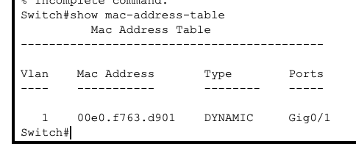

d) It displays the Mac Address of a device that is connected to the Router on Gig0/1 port. This displays that the Routers learns on its own about the Mac address of the devices that are connected to it.

E, f)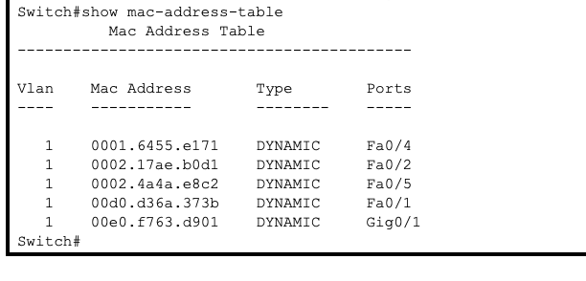 Here is the screenshot of MAC-address-table

After pinging from one device to another each Mac addresses are stored in the MAC-address-table along with their Type and Ports.

G)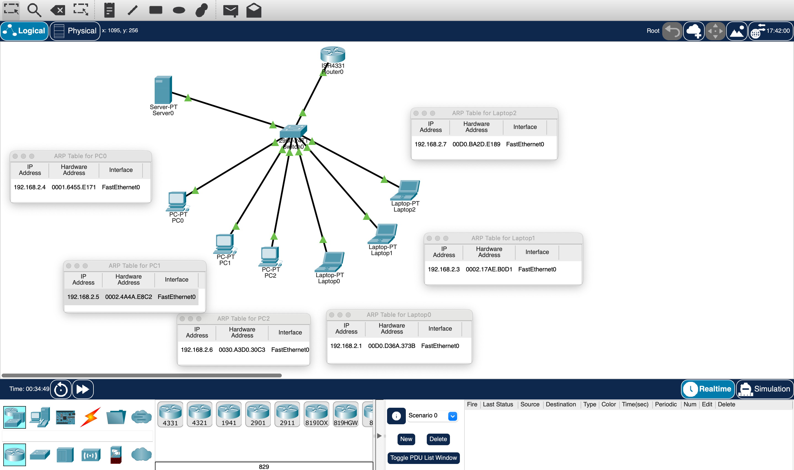

In each device ARP table, IP addresses and Mac address are stored to maps MAC addresses to IP addresses for efficient communication in a network, improving data transmission speeds.

h) The ARP table will change when we ping from one device to another, the Mac address of that device which we are communicating with will be stored in the ARP table for efficient communication in the future.

**2. Clear the mac address table from the switch. You can do this by using “clear mac-**

**address-table” command in CLI of the switch.**

**a. Configure server as a DHCP server and use DHCP to obtain IP address for all PCs**

**and laptops.**

**b. Check the arp table of PCs and laptops. Compare you observation with what you**

**have recorded in 1.b).**

**c. Check the Mac table of the switch. Compare and explain you observation with**

**what you have recorded in 1.c)**

**Ans.**

1. Here are the configuration for the DHCP server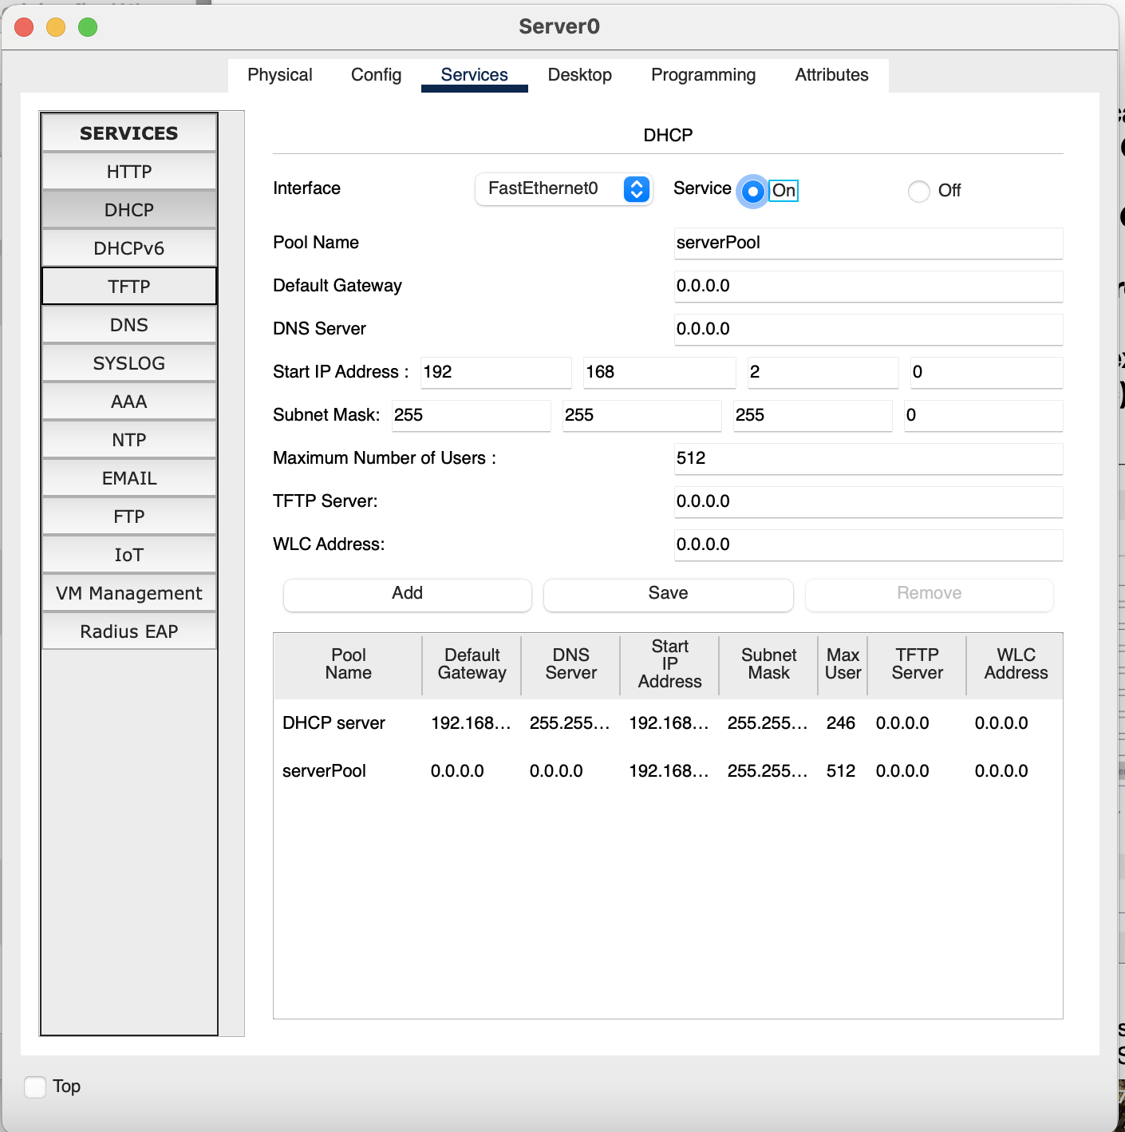

B, c) We have set up the DHCP configuration for each device and checked the ARP table of each device after pinging. Here are the ARP table of each device after the pinging from one device to another.

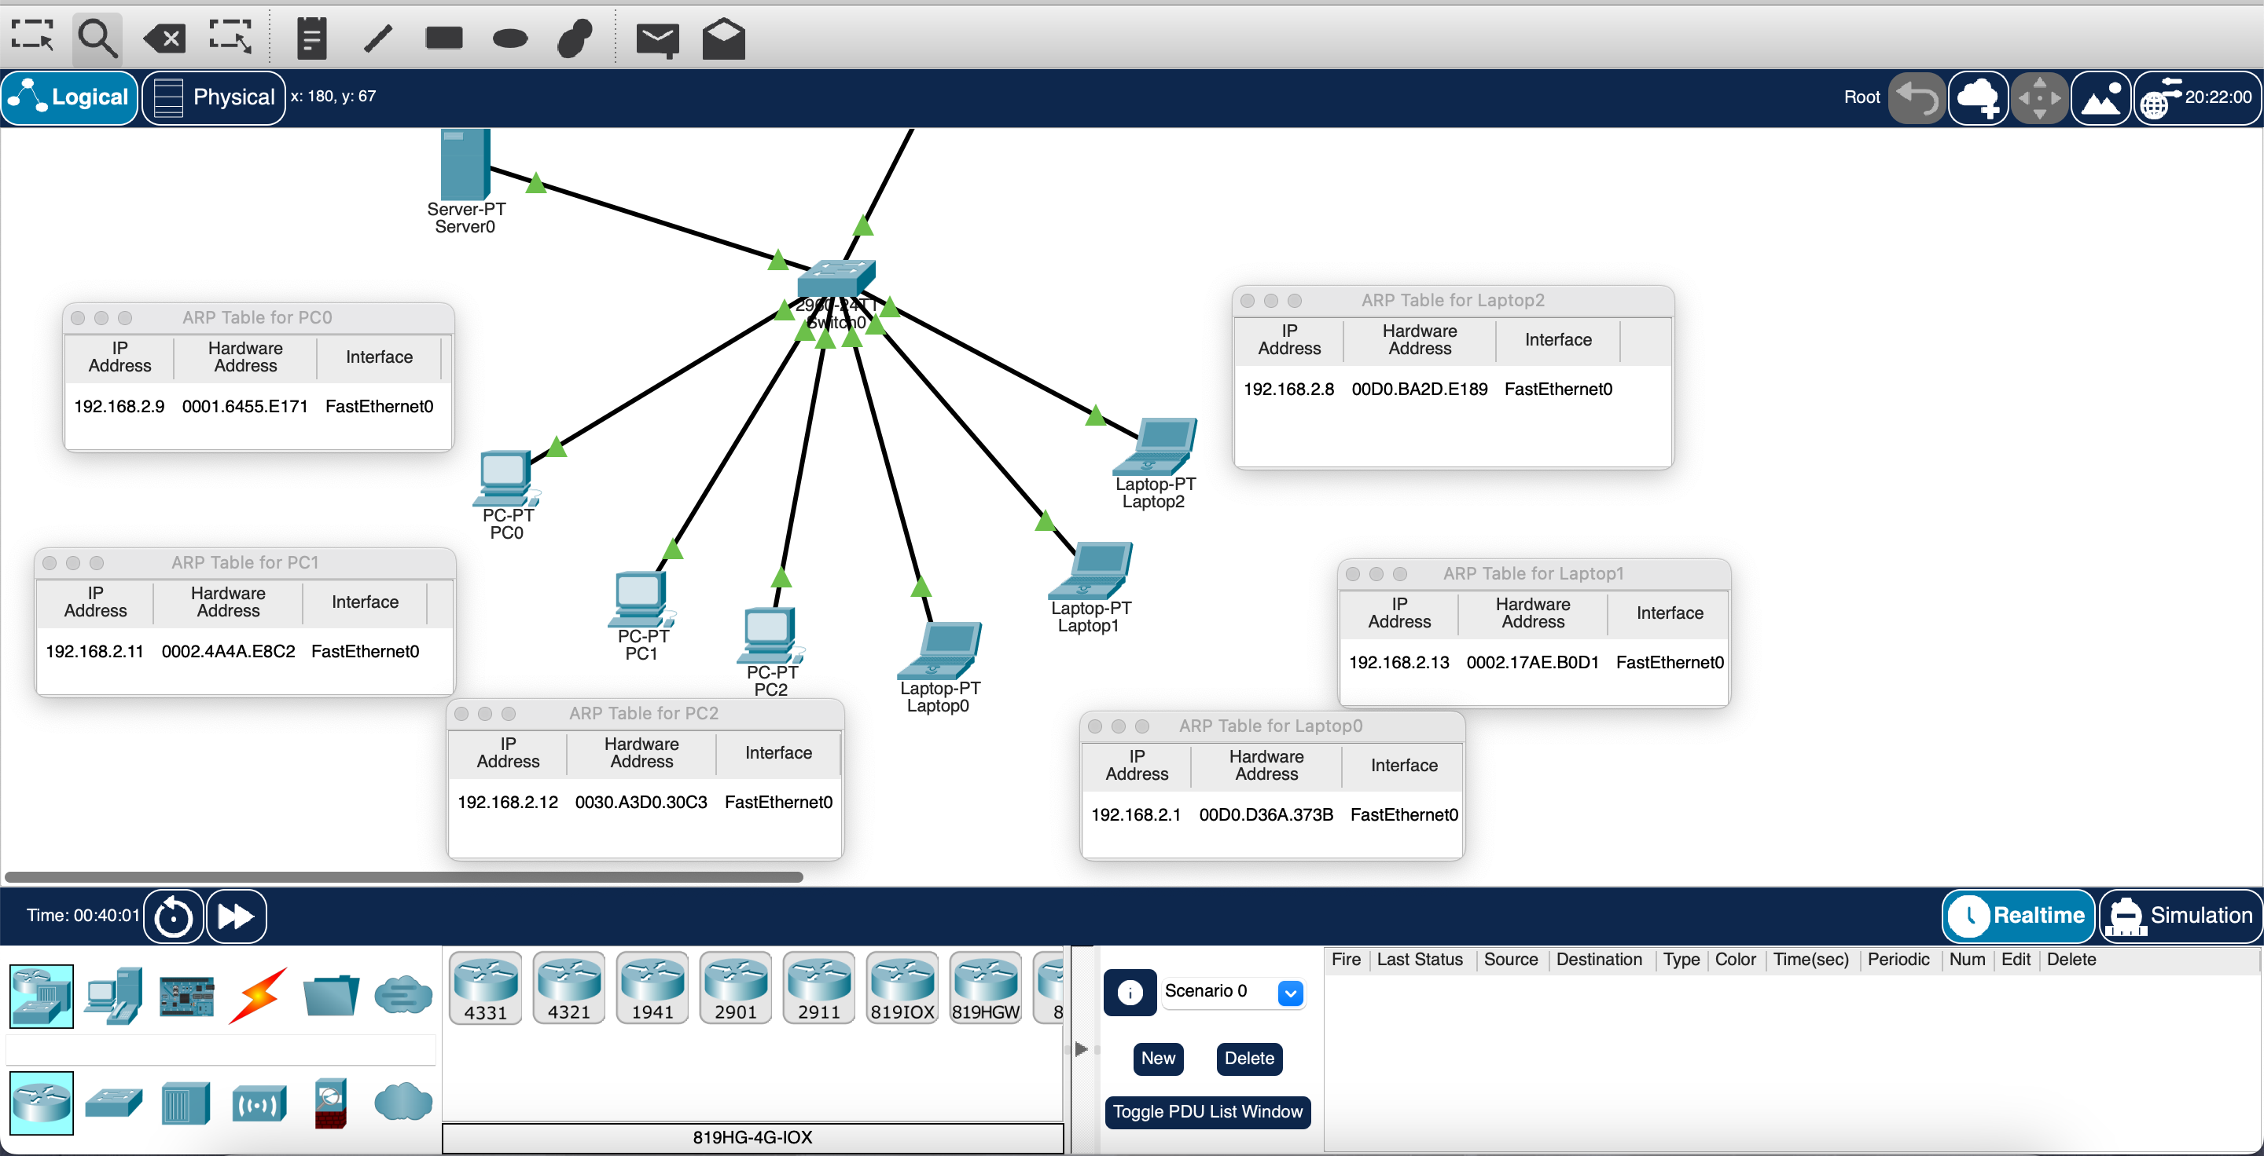

The IP addresses are different after setting up the DHCP server. Here are the Mac address of each device on switch after the DHCP server.

